Azure Configuration

1. Pre-requisites: We should have Azure subscription / membership.
2. Login
   1. Go to Azure URL:
      1. <https://portal.azure.com>
   2. Login using your credentials (Mindtree AD credentials)
3. Create new web app under “App Service” to deploy application in Azure environment.
   1. Click App Services -> Click Add

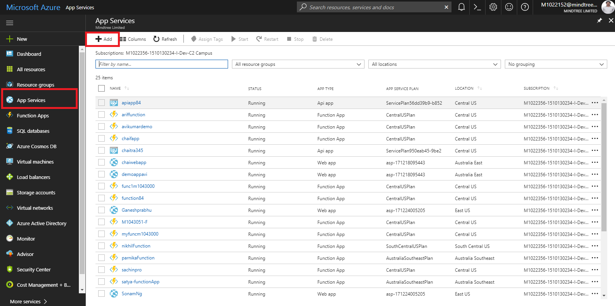

* 1. Click on “Web App” -> Click on “Create Button” as in the below screenshot.

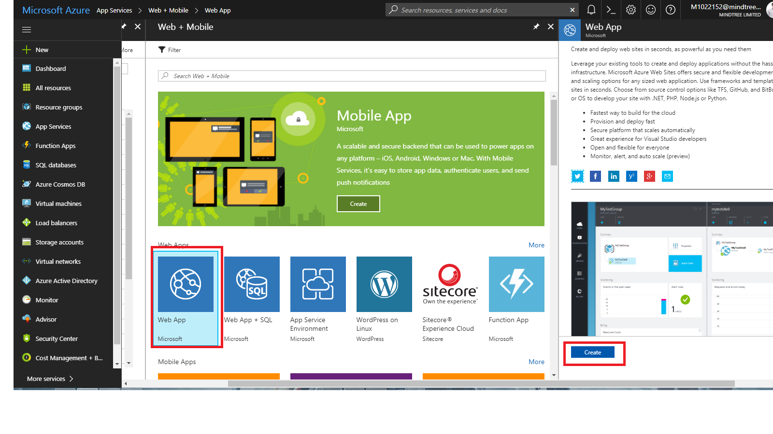

Then provide App Details as shown below like “Appname”

If you are having a resource group use the existing one otherwise create a new one.

Then click create.

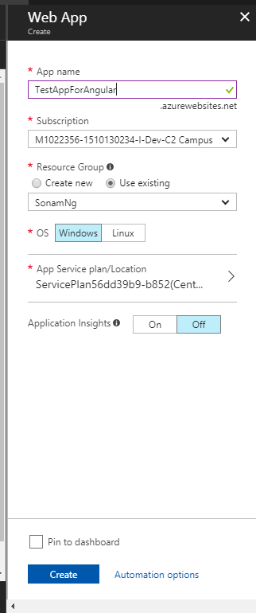

Once we created, we have to go to the resources folder (Go to “App Services” left menu and choose the recently created web app service)

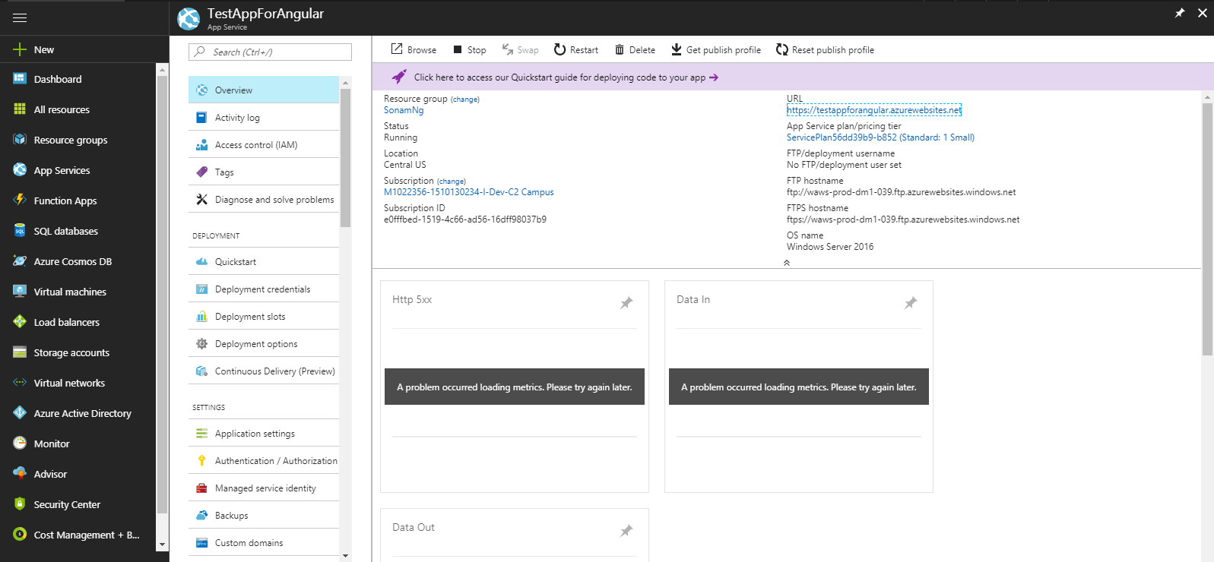

To check the web app service up and running by browsing the “URL” in the “Overview” section

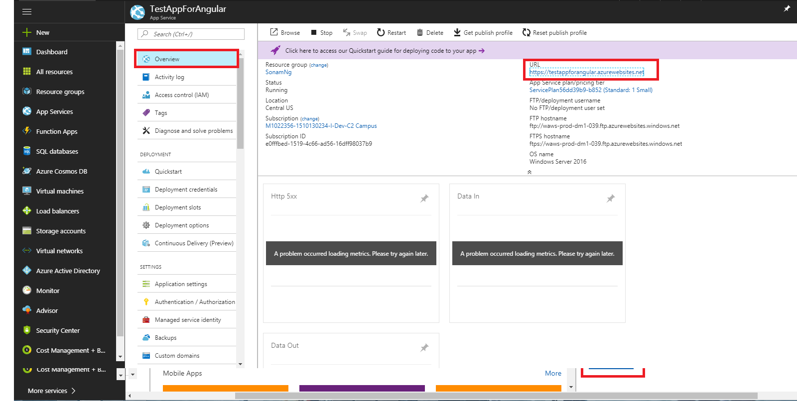

If the App Service is up and running successfully then, we can find the service screen as below:

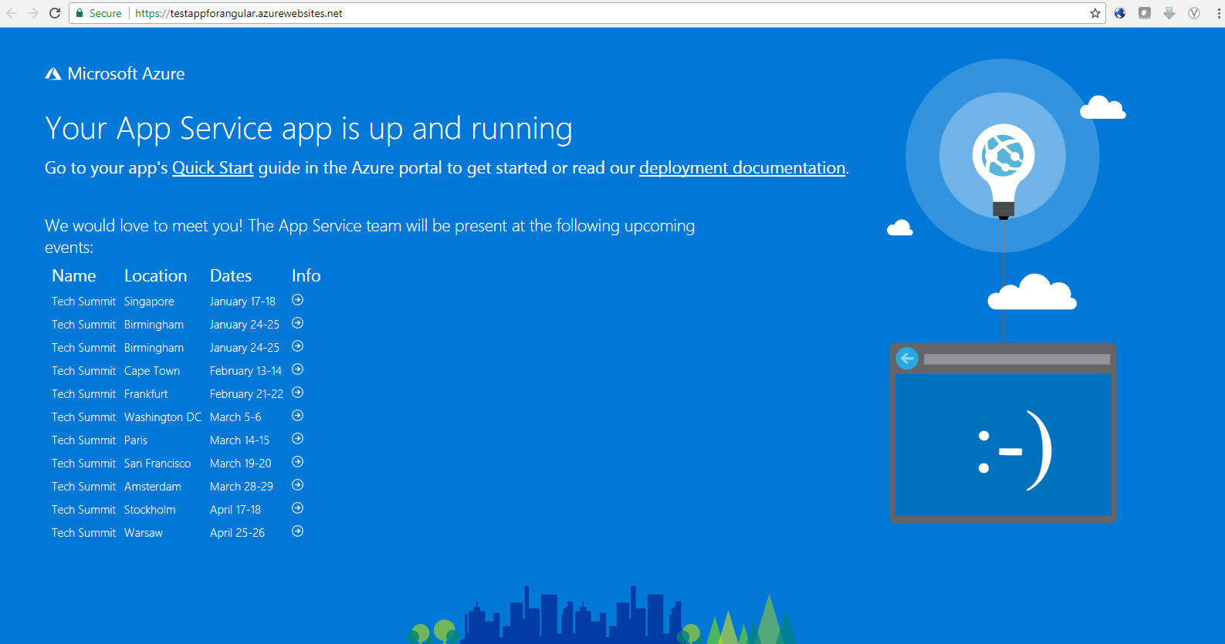

Once its up and run then create the deployment credentials as shown below:

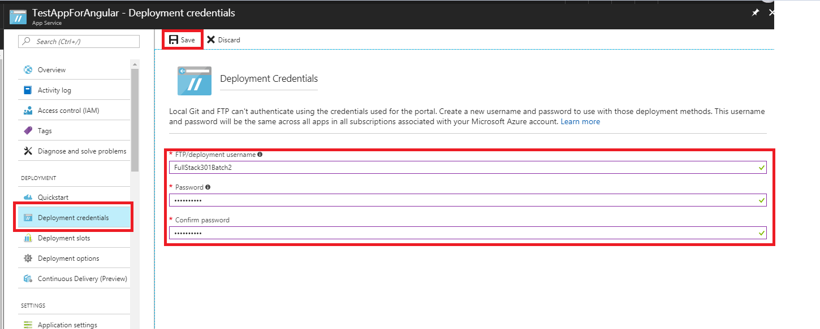

Application Settings Section:

We can configure the “Start Up Documents” and “Start Up directories” in this section

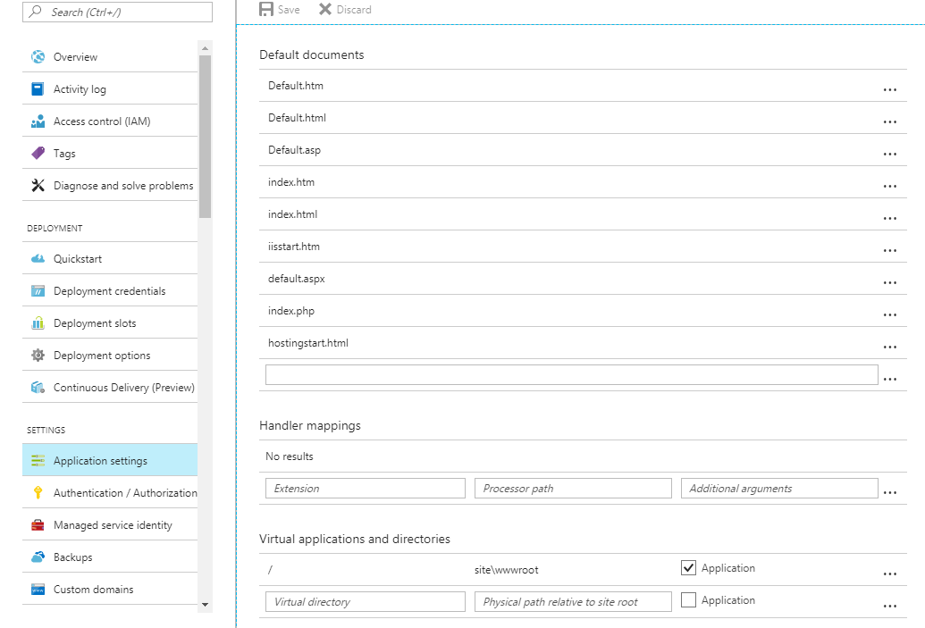

**Configuring Azure FTP Details in Jekins:**

Go to Jenkin URL -> Click “Manage Jenkins”. -> Click “Configure System”.

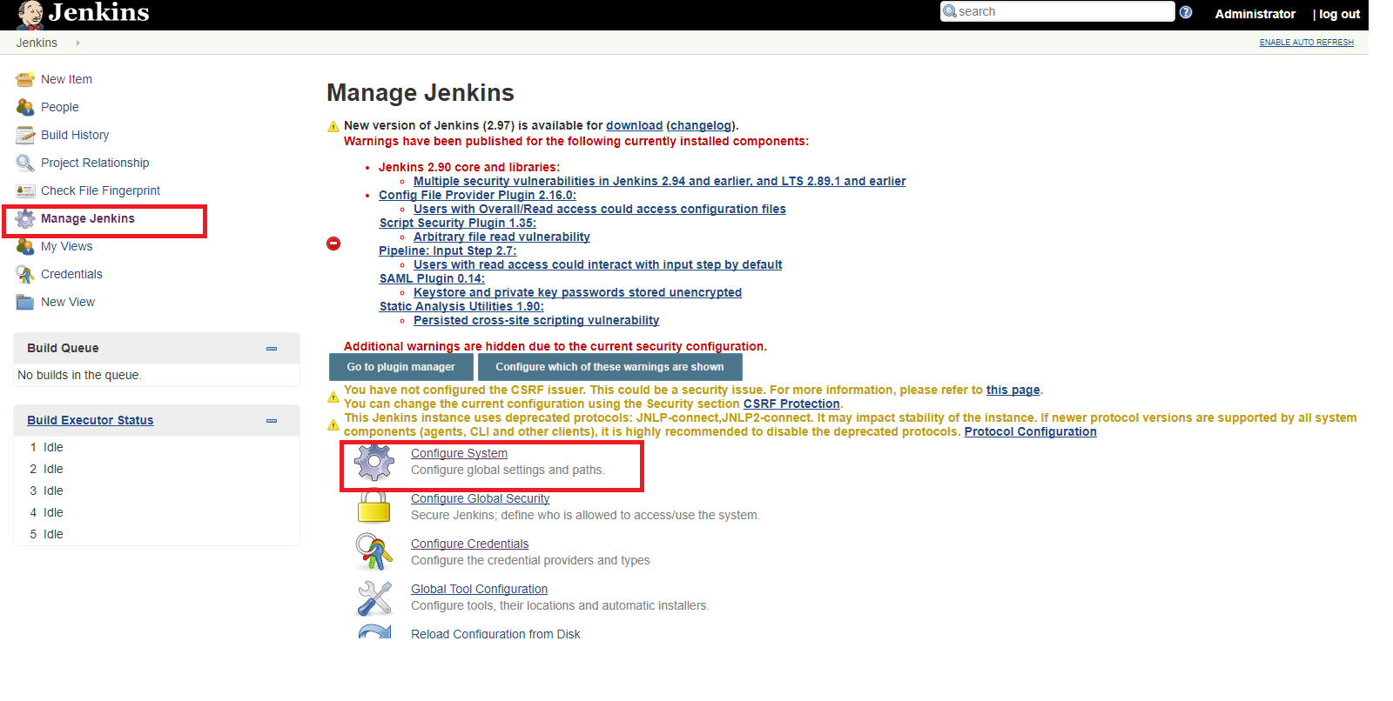

In “Publish over FTP” Section -> Click Add button

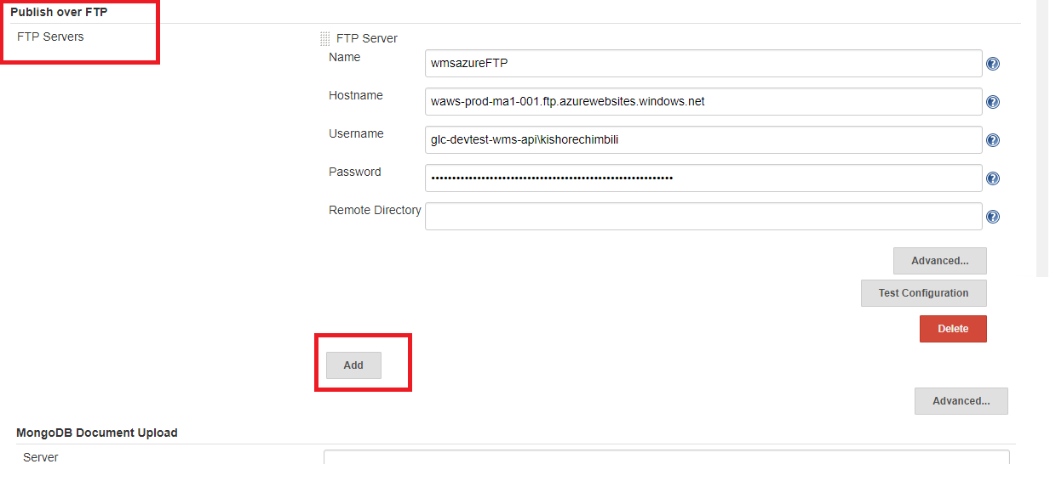

Configure FTP details with deployment credentials provided during azure app service creation. As shown below. Then click on Add.

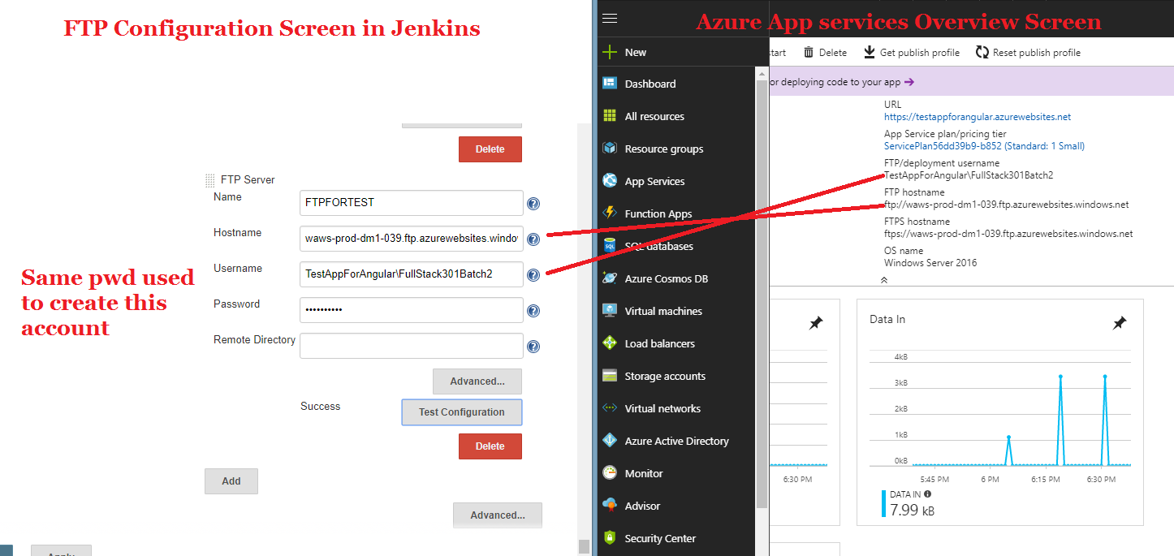

Testing the FTP Connection Click “Test Configuration”.

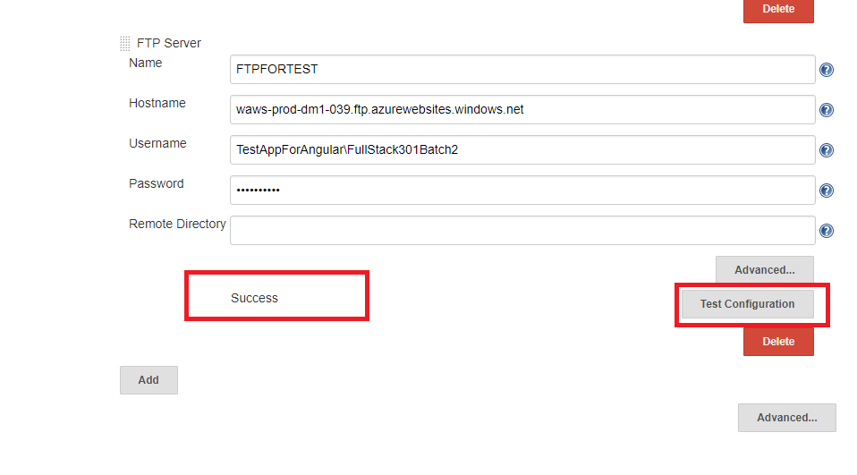

Once added the FTP location details. Go to the Jenkins Configuration “Post build action” section -> Click “Add post-build action” and Select “Send build artifacts over FTP”

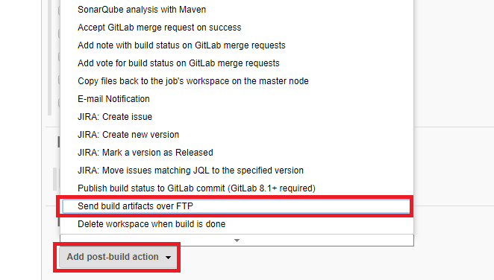

Select the FTP name and configure the source files and remote directory details. Then click “Apply” and “Save”.

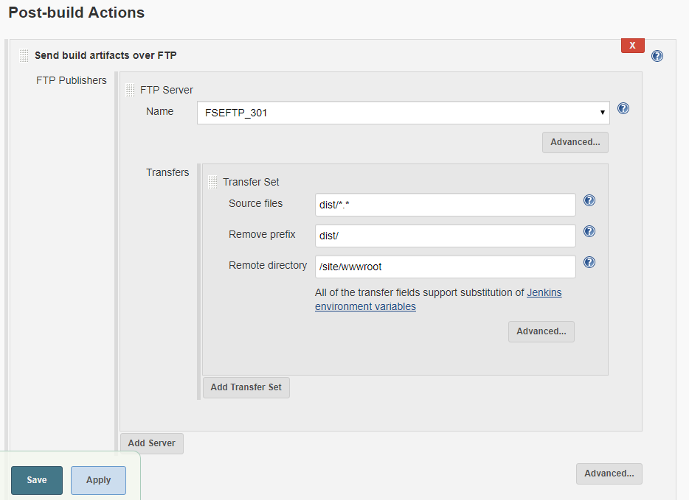

Then trigger a build event in Jenkins and browse the site.

**Testing the azure web sites:**

We can use the KUDU feature provided by the Azure platform. To use we can add “.scm” before the domain: For Ex: <https://testappforangular.scm.azurewebsites.net/>

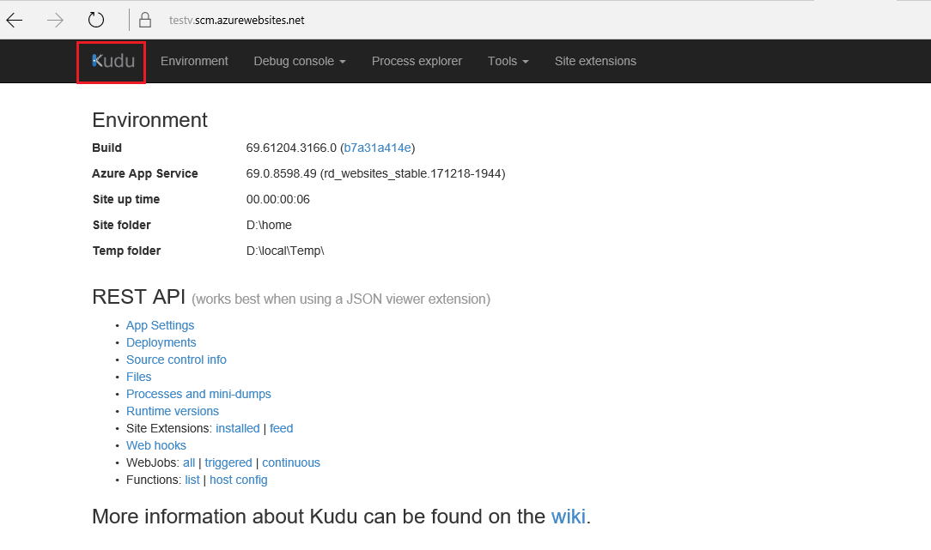

Then click “Debug Console” menu and select “CMD” option. We can able to see the deployed codes:

